**Power Analysis using G*Power**

**What is statistical power?**

|  |  |  |  |
| --- | --- | --- | --- |
|  | | Study finding | |
| **Effect present** | **Effect absent** |
| State of the world | **Effect present** | Reject Ho | Type II error (miss) |
| **Effect absent** | Type I error (false alarm) | Retain Ho |

Desired outcomes:

* Probability of type I error (α) less than 5% (p≤.05)
* Probability of Type II error (β) less than 20% (1- β ≥80%)

**Effect size**

* Alpha (i.e., *p* value) only states *whether* an effect is statistically significant
* Magnitude of effect in sample is also important
  + With enough data, 1% improvement/difference may be significant
  + With too little data, a 50% improvement/difference may be non-significant
* If *p* is greater than .05, effect size is still informative

**Underpowered study consequences**

* Cannot know whether
  + Effect does not exist

OR

* + Effect exist, but study was underpowered (i.e., not enough data to detect it)
* If study is conducted, participants are put at risk without hope of valid conclusion or benefits
* A potentially effective treatment may be overlooked

**Required sample size is determined by 3 inputs**

* Chosen alpha
* Chosen power
* Expected effect size

**What effect size to expect**

* Review previous literature studying similar effects and note reported effect sizes
  + Cohen’s d or Hedges’s g
  + Eta (η, η2)
  + Omega (ω, ω2)
  + Pearson’s *r*
  + If none of the above, note means and SDs
* Statistical tests used in previous lit does not have to be identical to those appropriate to your study’s design

Cohen (1992) Table 1, p.157, lists a number of effect sizes, for interpretation purposes.

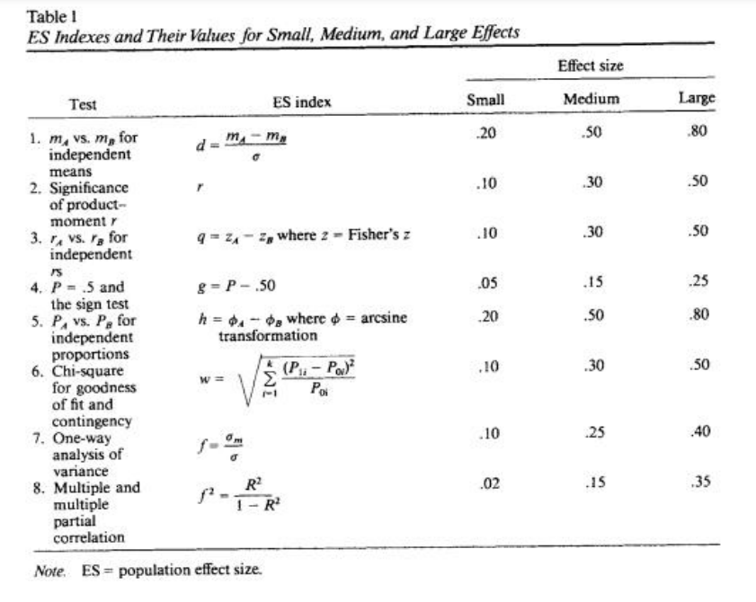

**Download G*Power:** <https://www.psychologie.hhu.de/arbeitsgruppen/allgemeine-psychologie-und-arbeitspsychologie/gpower>

**Case studies using G*Power**

* Independent sample t test (e.g., treatment vs placebo group)
* Pearson’s R correlation test
* Multiple Regression

References:

Charan, J. & Biswas, T. (2013). How to Calculate Sample Size for Different Study Designs in Medical Research? *Indian J Psychology Medicine, 35*(2): 121–126. doi: 10.4103/0253-7176.116232

[Cohen](https://journals.sagepub.com/doi/abs/10.1111/1467-8721.ep10768783), J. (1992). A Power Primer. *Psychological Bulletin, 112*(1), 155-159.

[Dziak](https://pubmed.ncbi.nlm.nih.gov/?term=Dziak%20JJ%5BAuthor%5D), J., [Dierker](https://pubmed.ncbi.nlm.nih.gov/?term=Dierker%20LC%5BAuthor%5D), L. & Abar, B. (2020). The Interpretation of Statistical Power after the Data have been Gathered. *Curr Psychol, 39*(3): 870–877. doi: [10.1007/s12144-018-0018-1](https://doi.org/10.1007%2Fs12144-018-0018-1)

Glazek, K. (2017). Power Analysis Using G*Power Software: An Applied Guide. Video. National Center for Academic and Dissertation Excellence. <https://www.youtube.com/watch?v=CSBCKVQLf8c&t=2989s>